**Getting Started**

Start by installing and running [Visual Studio 2017](https://www.visualstudio.com/).

Visual Studio is an IDE, or integrated development environment. Just like you use Microsoft Word to write documents, you'll use an IDE to create applications. In Visual Studio there's a list along the bottom showing various options available to you. There's also a menu that provides another way to perform tasks in the IDE. (For example, instead of selecting **New Project** from the **Start** page, you can use the menu and select **File** > **New Project**.)

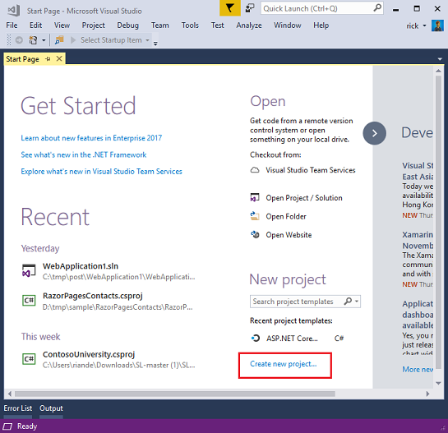

**Creating Your First Application**

Click **New Project**, then select Visual C# on the left, then **Web** and then select **ASP.NET Web Application (.NET Framework)**. Name your project "MvcMovie" and then click **OK**.

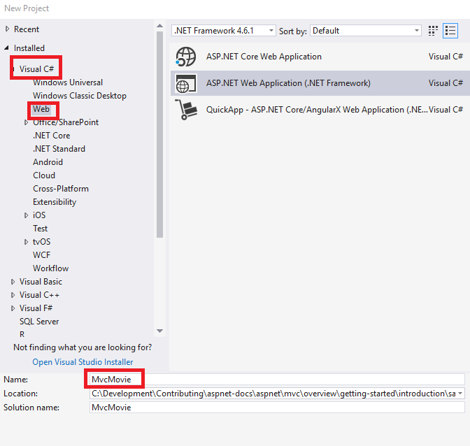

In the **New ASP.NET Project** dialog, click **MVC** and then click **OK**.

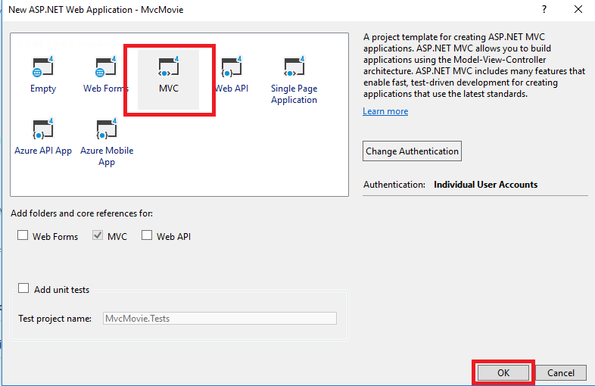

Visual Studio used a default template for the ASP.NET MVC project you just created, so you have a working application right now without doing anything! This is a simple "Hello World!" project, and it's a good place to start your application.

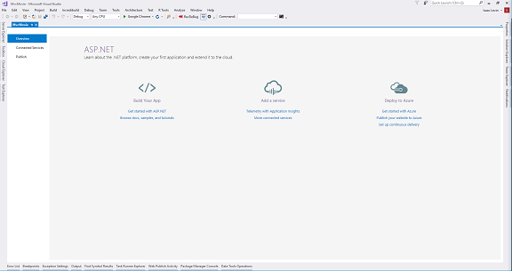

Click F5 to start debugging. F5 causes Visual Studio to start [IIS Express](https://www.iis.net/learn/extensions/introduction-to-iis-express/iis-express-overview) and run your web app. Visual Studio then launches a browser and opens the application's home page. Notice that the address bar of the browser says localhost:port# and not something like example.com. That's because localhost always points to your own local computer, which in this case is running the application you just built. When Visual Studio runs a web project, a random port is used for the web server. In the image below, the port number is 1234. When you run the application, you'll see a different port number.

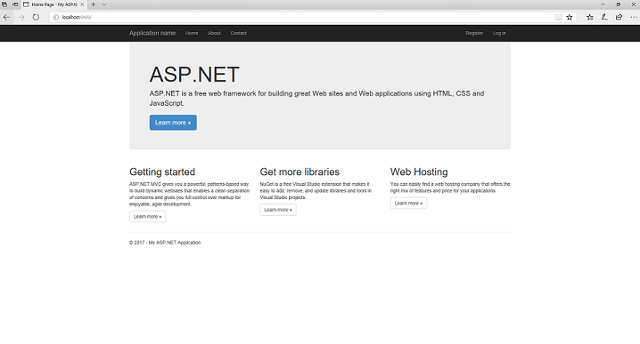

Right out of the box this default template gives you Home, Contact and About pages. The image above doesn't show the **Home**, **About** and **Contact** links. Depending on the size of your browser window, you might need to click the navigation icon to see these links.

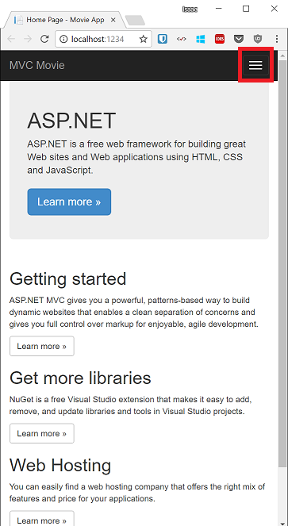

The application also provides support to register and log in. The next step is to change how this application works and learn a little bit about ASP.NET MVC. Close the ASP.NET MVC application and let's change some code.